TECHNICAL PROJECT REPORT

# Title of Invention / Project:

AUTOMATIC NIGHT LAMP USING O/P AMPLIFIER

# Team Members / Inventors:

|  |  |  |  |  |  |
| --- | --- | --- | --- | --- | --- |
| **S. No.** | **Name** | **Department** | **Designation** | **Mobile** | **E-Mail** |
| 1. | Shweta Sharma | CSE(IOT) | Student | 9805088451 | [Shwetaprabhakar091@gmail.com](mailto:Shwetaprabhakar091@gmail.com) |
| 2. | Sameksha | CSE(IOT) | Student | 6283607445 | [samekshapandhi@gmail.com](mailto:samekshapandhi@gmail.com) |
| 5. | Khushal Thakur | ECE | Mentor | 9646030764 | [khushal.thakur@cumail.in](mailto:khushal.thakur@cumail.in) |
| 6. | Anshul Sharma | ECE | Mentor | 9478697475 | [anshulsharma.ece@cumail.in](mailto:anshulsharma.ece@cumail.in) |
| 7. | Kiran Jot Singh | ECE | Mentor | 9463909689 | [kiranjotsingh.ece@cumal.in](mailto:kiranjotsingh.ece@cumal.in) |
| 8. | Divneet Singh Kapoor | ECE | Mentor | 9878422653 | [divneet.ece@cumail.in](mailto:divneet.ece@cumail.in) |

Section – 1 (IPR Related)

# Brief Abstract (500 words):

* Problem your project is solving

Nowadays the wastage of electricity has become a routine thing for us, and the problem has become frequent at homes, schools, and colleges and even in industries. Sometimes we notice fans and lights keep on working even in the absence of people. This often happens in homes, offices and public places due to utter negligence of the inmates.

However, there is a solution to control energy efficient lights at home by using automatic room light controller.

* How are you solving that (solution)?

The light of the house will be controlled using a light sensor called LDR for automatically switching on the lights when room light or atmospheric light is less and turns it off in case of abundant sunlight. Also, the output is connected to AC bulb that switches on with a relay when the light is low and turns off when there is ambient light in the room.

* Additional modifications that can cater to improved solution

Cost of LDR based bulb using op-amp is very much lower than arduino based LDR bulb. So, it will be cost efficient providing same output as in arduino based LDR light.

# Existing state-of-the-art and Drawbacks in existing state-of-the-art

(*Brief background of the existing knowledge*)

|  |  |  |
| --- | --- | --- |
| **S. No.** | **Existing state of art** | **Drawbacks in existing state of art** |
| 1 | CN207075103U-ENERGY SAVING STREET LAMP | IT IS COSTLY |

# Novel/Additional modifications that you can propose to improve upon drawbacks

*(List down the features)*

* Feature 1

Using op amp comparators instead of arduino

# Advantages

* Adv 1:

It is cost efficient. Everyone can afford this.

* Adv 2:

Helps in saving electricity as it will turn only in darkness and in light will automatically turn off.

# BLOCK DIAGRAM

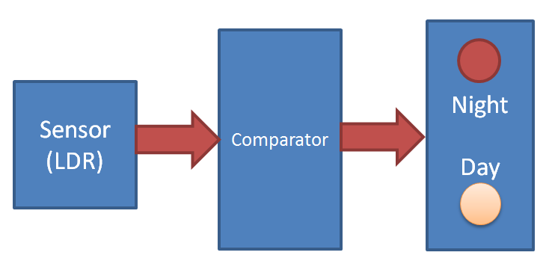

Section – 2 (Real Project)

# Materials

|  |  |  |  |  |
| --- | --- | --- | --- | --- |
| S.NO | Name | Quantity | Colour | Pins |
|  | LDR | 1 | - | 2 |
|  | Trimmer  Variable Resistance  10 k ohm | 1 | Blue | 3 |
|  | LM358 Operational Amplifier | 1 | - | 8 |
|  | IC Base (8, 16pin) | 1 | Black | 16 |
|  | ULN2003 IC | 1 | Black | 16 |
|  | SPDT Relay | 1 | White | 5 |
|  | Battery ( 9v) + Connector  ( optional ) | 1 |  | - |
|  | Ribbon wires | - | - | - |
|  | General purpose PCB | 1 | - | - |

# Circuit Diagram

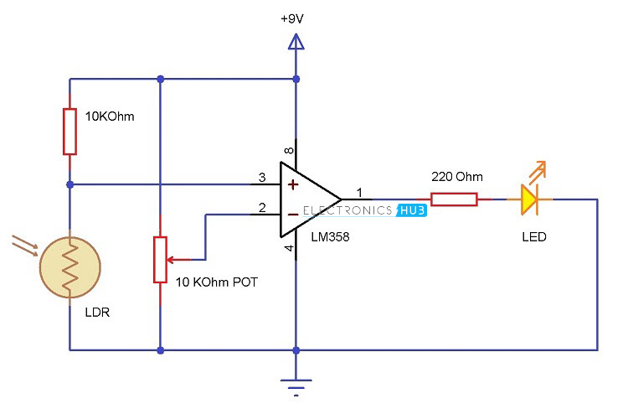

# Steps of Circuit Completion

